Statement of Educational Effectiveness

The ATS and HLC call for all accredited schools to post public statements of educational effectiveness. To do so Eden has assembled data from student demographics, graduation and placement rates, default rates from our graduates who participate in the Federal Student Loan Program, and various student surveys regarding satisfaction with Eden’s programs and the post-graduation experience.

Student Demographics and Diversity

A key component of the Eden educational experience is the diversity of our community of faith and learning (denominationally, racial-ethnically, and internationally). The Eden faculty is made of 8 teachers and scholars, 6 women and 2 men. One third of Eden’s faculty is racial-ethnic minorities. Eden’s student body is ecumenically diverse, (33% UCC, 12 % UMC, and the remaining 55% an array of other denominations and traditions, e.g., DOC, AME, CME, MCC, Episc, PCUSA, Baptist, ELCA; Unitarian, and non-denominational) and racial-ethnically diverse (31% African-American).

Eden is an[Open and Affirming Seminary of the United Church of Christ](http://www.ucc.org/lgbt/ona.html).

Eden engages in a vigorous program of international educational partnerships that currently hosts 3 students from 3 countries in our various degree programs. These students use their Eden education as a means to empower their teaching and leadership of the Church in their countries. In addition to the church in North America, dozens of Eden graduates since 2000 lead the Church in China, India, New Zealand, South Africa, Lesotho, Malawi, Ghana, Kenya, Tanzania, Zambia, Fiji, Solomon Islands, Philippines, South Korea,  and the Isle of Mann.

Graduation/Retention Rate

As a graduate professional school, Eden challenges students with a rigorous course of study that is accountable to the expectations of various denominational bodies for formation for ministry.  As such, while Eden works hard to support students in their progress toward degree, admission is not insurance of graduation. Students must maintain a minimum GPA, pass a comprehensive examination of the goals of the curriculum at each level, and complete 6 semesters of Contextual Education (evaluated by supervising ministers) in various settings of ministry. Nonetheless, Eden’s graduation rates* are strong.

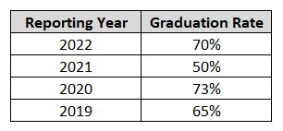Remove the current grid and replace with attachment titled graduation rate (as shown below)



*\*Graduation rates are reported based on time periods defined by the Association of Theological Schools (ATS) annual reporting requirements.*

Eden defines its retention rate as the percentage of students enrolled in a degree program from one year to the next, excluding those who have graduated in the interim. The results below reflect retention between Fall 2021 and Fall 2022.

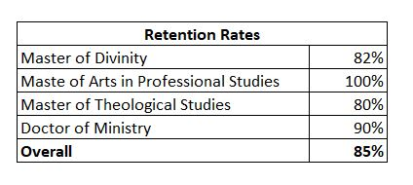

Placement Rate

Eden’s placement data is collected from students who graduated the prior spring. The placement rate for Eden’s Class of 2022 is 85%

Loan Default and Debt Management

Eden’s default rate in the Federal Loan program is on average low, and Eden’s program of financial literacy and counseling has been noted by the Missouri Department of Education as a model program. The low rate can be seen as one indicator that Eden’s graduates attain gainful employment post graduation.

Remove the current grid and replace with attachment titled cohort default rate (as shown below)

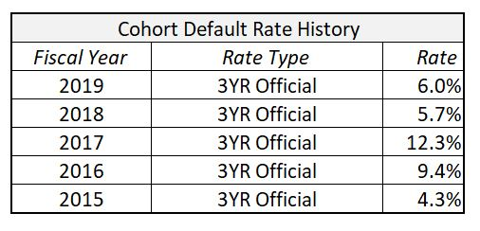

Student Satisfaction

Annually, Eden participates in a survey of graduating students administered by the ATS.  Here are the results of the 2021-22 survey.

Remove the current grid and replace with attachment titled student satisfaction (as shown below)

